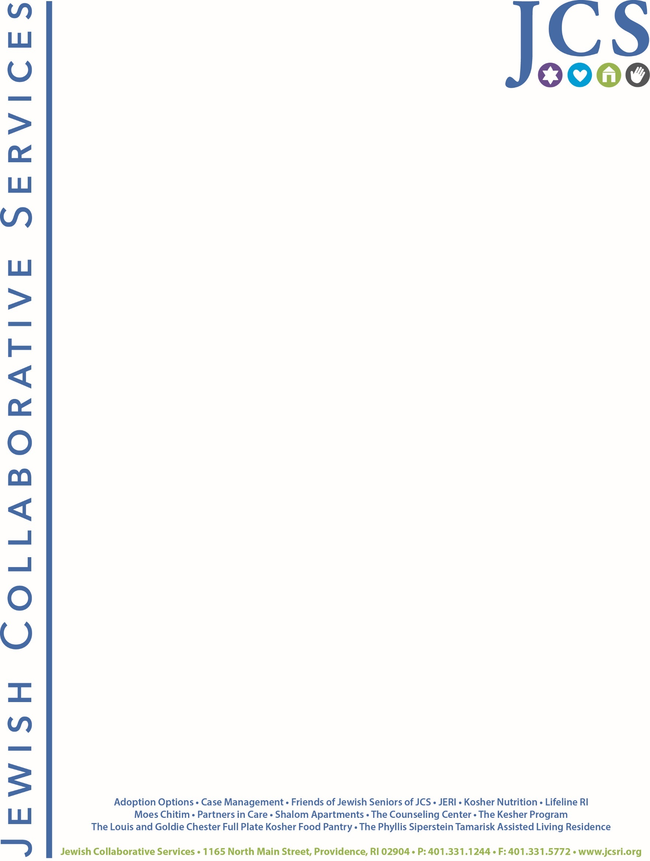

September 25, 2020

In accordance with Jewish Collaborative Services bylaw, Article V Section 4, the   
following names will be submitted in nomination to the Board of Directors at   
JCS’ Annual Meeting on October 22, 2020:

Joie Magnone  
Nicole Jellinek  
Kayla Rosen  
Ron Markoff

Nominees for the slate of officers are:  
  
Marisa Garber – President

Mindy Stone – Vice-President

Richard Licht – Treasurer

Minna Ellison – Secretary

Respectfully submitted,

Mindy Stone

Mindy Stone  
  
MS/df